CIA-1

1. Q1

package cc2;

import org.testng.Assert;

import org.testng.annotations.AfterMethod;

import org.testng.annotations.BeforeMethod;

import org.testng.annotations.Test;

import org.openqa.selenium.By;

import org.openqa.selenium.WebDriver;

import org.openqa.selenium.chrome.ChromeDriver;

import org.openqa.selenium.chrome.ChromeOptions;

import io.github.bonigarcia.wdm.WebDriverManager;

public class Task1 {

WebDriver driver;

*@BeforeMethod*

public void setup() {

WebDriverManager.*chromedriver*().setup ();

ChromeOptions co=new ChromeOptions();

co.addArguments ("--remote-allow-origins=*");

driver=new ChromeDriver(co);

driver.navigate().to("https://www.amazon.in/Mandala-Colouring-Books-Adults-Sheets/dp/938653861X/ref=sr_1_1_sspa?crid=242QUV89NUJLI&keywords=book&qid=1683191364&sprefix=boo%2Caps%2C639&sr=8-1-spons&sp_csd=d2lkZ2V0TmFtZT1zcF9hdGY&psc=1");

driver.manage().window().maximize() ;

}

*@Test*

public void f() throws InterruptedException {

String currentTitle=driver.getTitle();

System.***out***.println(currentTitle);

Assert.*assertEquals*(currentTitle, "Mandala: Colouring books for Adults with tear out sheets : Wonder House Books: Amazon.in: Books");

driver.findElement(By.*xpath*("//*[@id=\"add-to-cart-button\"]")).click();

driver.findElement(By.*xpath*("//*[@id=\"nav-cart\"]")).click();

driver.findElement(By.*xpath*("//*[@id=\"a-autoid-0-announce\"]")).click();

driver.findElement(By.*xpath*("//*[@id=\"quantity_4\"]")).click();

Thread.*sleep*(1000);

driver.findElement(By.*xpath*("/html/body/div[1]/div[2]/div[3]/div[5]/div/div[2]/div[1]/div/form/div[2]/div[3]/div[4]/div/div[2]/div[1]/span[2]/span/input")).click();

driver.navigate().to("https://www.amazon.in/Mandala-Colouring-Books-Adults-Sheets/dp/938653861X/ref=sr_1_1_sspa?crid=242QUV89NUJLI&keywords=book&qid=1683191364&sprefix=boo%2Caps%2C639&sr=8-1-spons&sp_csd=d2lkZ2V0TmFtZT1zcF9hdGY&psc=1");

driver.findElement(By.*xpath*("//*[@id=\"add-to-cart-button\"]")).click();

driver.findElement(By.*xpath*("//*[@id=\"nav-cart\"]")).click();

driver.findElement(By.*xpath*("//*[@id=\"a-autoid-0-announce\"]")).click();

driver.findElement(By.*xpath*("//*[@id=\"quantity_4\"]")).click();

driver.findElement(By.*xpath*("/html/body/div[1]/div[2]/div[3]/div[5]/div/div[1]/div[1]/div/form/div/div[3]/span/span/span/input")).click();

Thread.*sleep*(1000);

driver.findElement(By.*xpath*("/html/body/div[1]/div[1]/div[2]/div/div[2]/div/div[1]/form/div/div/div/div[1]/input[1]")).sendKeys("keerthivarmanism@gmail.com");

driver.findElement(By.*xpath*("/html/body/div[1]/div[1]/div[2]/div/div[2]/div/div[1]/form/div/div/div/div[1]/input[1]")).click();

Thread.*sleep*(20000);

}

*@AfterMethod*

public void teardown() {

}

}

Output:

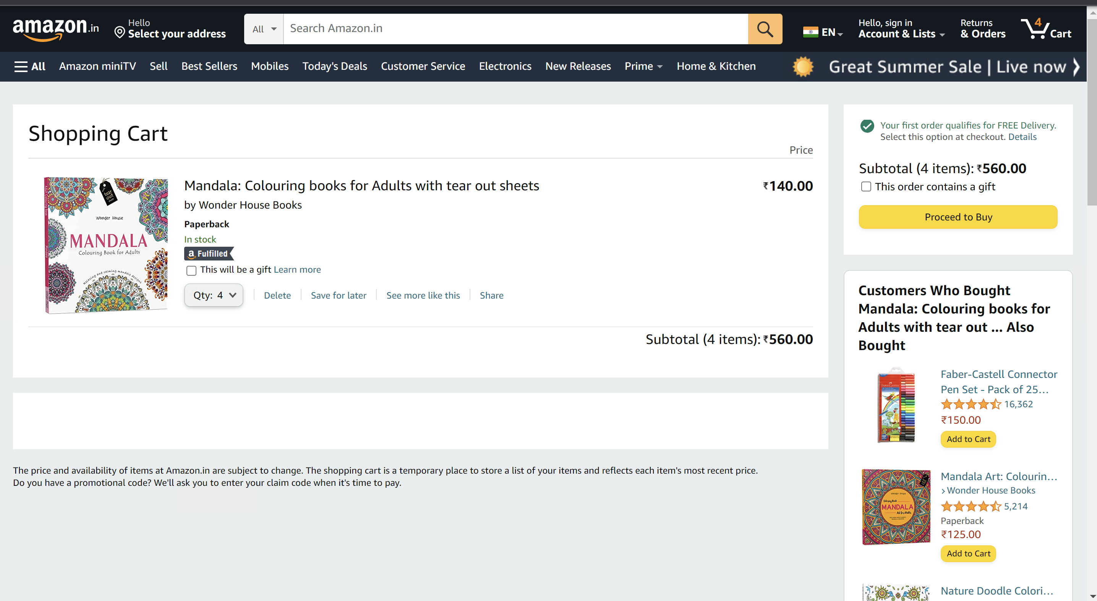

1. Q2

package cc2;

import org.openqa.selenium.By;

import org.openqa.selenium.WebDriver;

import org.openqa.selenium.WebElement;

import org.openqa.selenium.chrome.ChromeDriver;

import org.openqa.selenium.chrome.ChromeOptions;

import io.github.bonigarcia.wdm.WebDriverManager;

public class Task2{

public static void main(String[] args) {

// **TODO** Auto-generated method stub

ChromeOptions co=new ChromeOptions();

co.addArguments ("--remote-allow-origins=*");

WebDriverManager.*chromedriver*().setup ();

WebDriver driver=new ChromeDriver(co);

driver.get ("https://www.amazon.in/");

driver.manage().window().maximize() ;

String currentTitle=driver.getTitle();

System.***out***.println(currentTitle);

String expectedTitle="Online Shopping site in India: Shop Online for Mobiles, Books, Watches, Shoes and More - Amazon.in";

if(currentTitle.equals(expectedTitle)) {

System.***out***.println("Match found");

}

else {

System.***out***.println("not Matched");

}

WebElement txtBoxl=driver.findElement(By.*xpath*("//*[@id=\"twotabsearchtextbox\"]"));

txtBoxl.sendKeys("iphone");

driver.findElement(By.*xpath*("//*[@id=\"nav-search-submit-button\"]")).click();

String p1=driver.findElement(By.*xpath*("/html/body/div[1]/div[2]/div[1]/div[1]/div/span[1]/div[1]/div[3]/div/div/div/div/div/div/div/div[2]/div/div/div[1]/h2/a/span")).getText();

System.***out***.println(p1);

String p2=driver.findElement(By.*xpath*("/html/body/div[1]/div[2]/div[1]/div[1]/div/span[1]/div[1]/div[4]/div/div/div/div/div/div/div/div[2]/div/div/div[1]/h2/a/span")).getText();

System.***out***.println(p2);

String p3=driver.findElement(By.*xpath*("/html/body/div[1]/div[2]/div[1]/div[1]/div/span[1]/div[1]/div[4]/div/div/div/div/div/div/div/div[2]/div/div/div[1]/h2/a/span")).getText();

System.***out***.println(p3);

String p4=driver.findElement(By.*xpath*("/html/body/div[1]/div[2]/div[1]/div[1]/div/span[1]/div[1]/div[6]/div/div/div/div/div/div[2]/div/div/div[1]/h2/a/span")).getText();

System.***out***.println(p4);

String p5=driver.findElement(By.*xpath*("/html/body/div[1]/div[2]/div[1]/div[1]/div/span[1]/div[1]/div[7]/div/div/div/div/div/div[2]/div/div/div[1]/h2/a/span")).getText();

System.***out***.println(p5);

driver.findElement(By.*xpath*("//*[@id=\"p_72/1318476031\"]/span/a/section/i")).click();

System.***out***.println("the filter works");

}

}

Output:

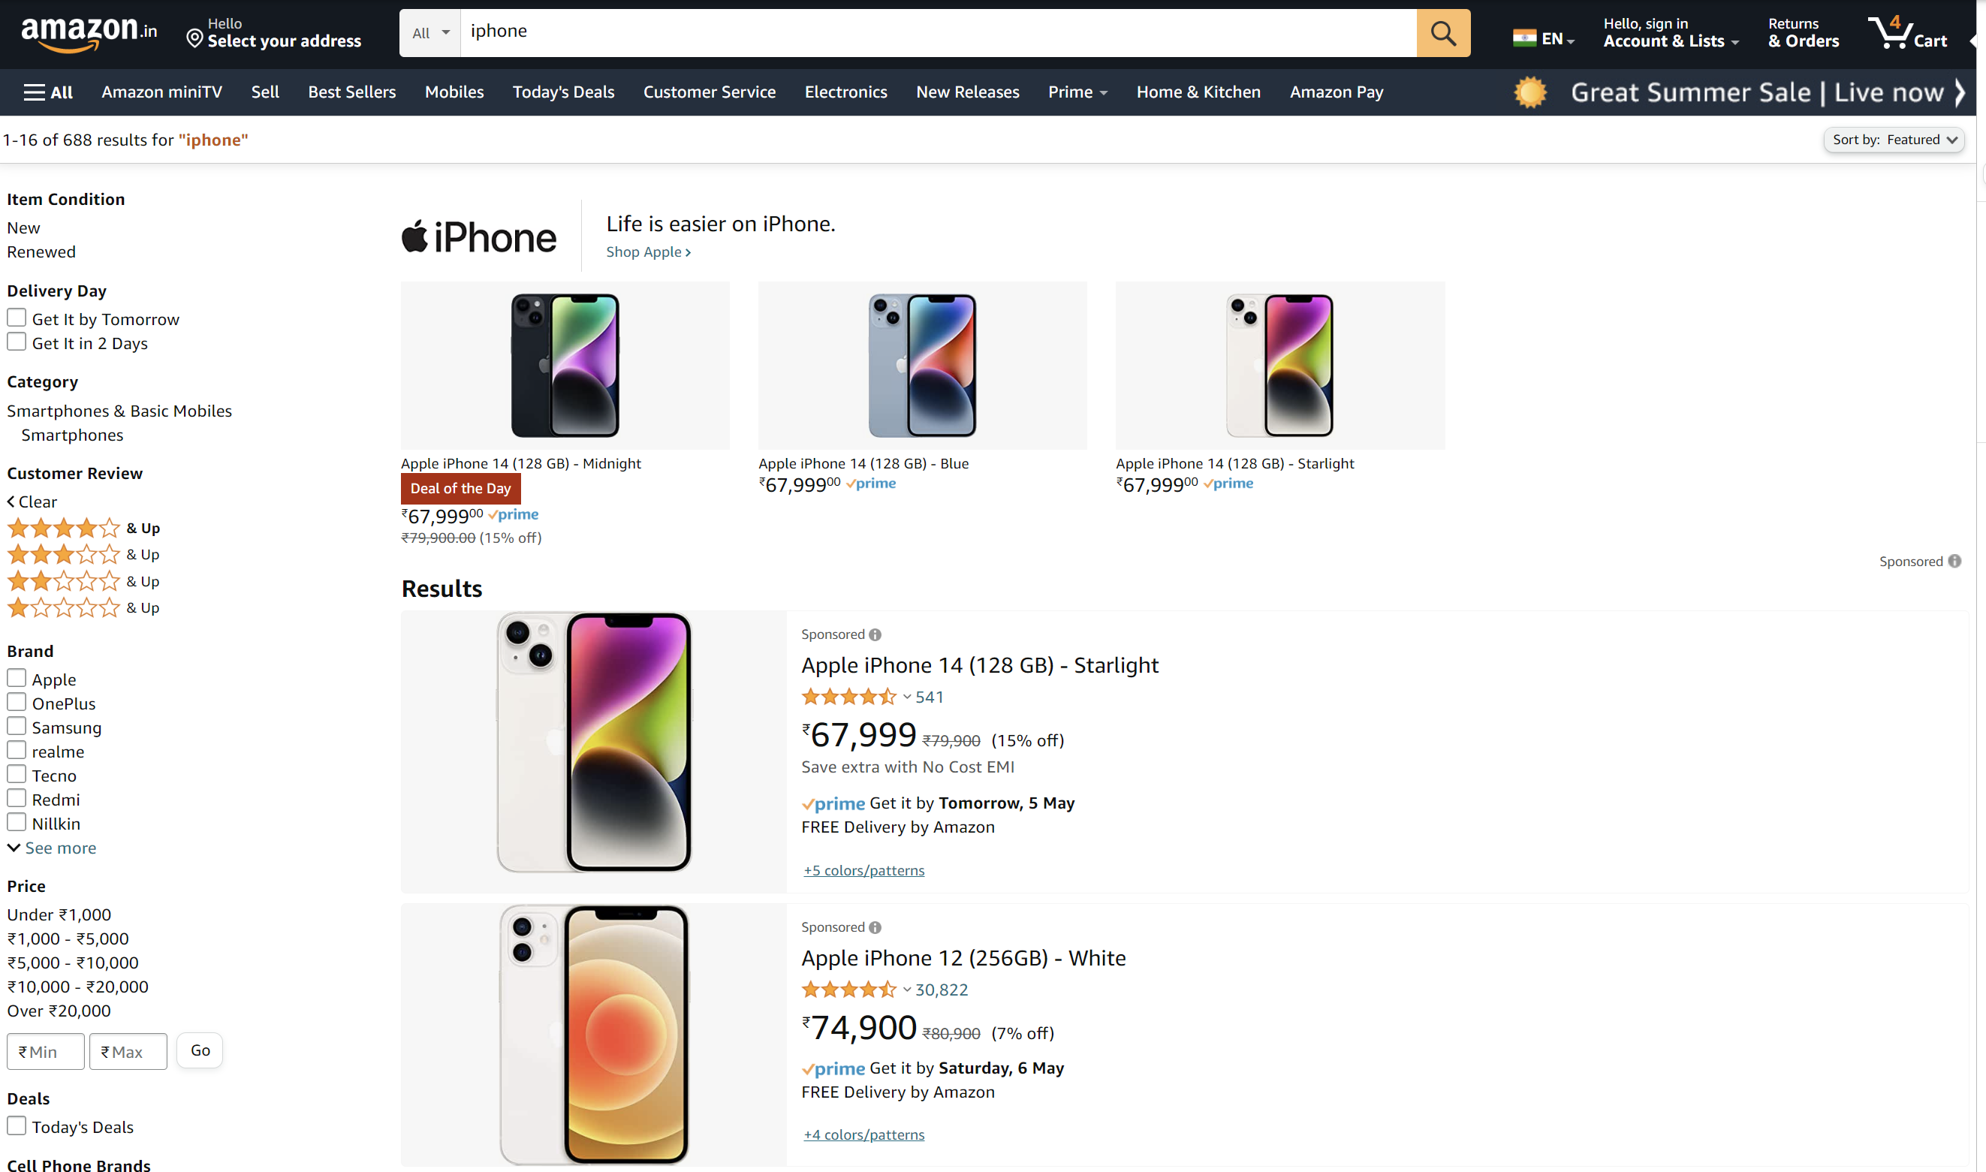

1. Q3
2. package cc2;
3. import org.openqa.selenium.By;
4. import org.openqa.selenium.WebDriver;
5. import org.openqa.selenium.WebElement;
6. import org.openqa.selenium.chrome.ChromeDriver;
7. import org.openqa.selenium.chrome.ChromeOptions;
8. import io.github.bonigarcia.wdm.WebDriverManager;
9. public class Task3 {
10. public static void main(String[] args) throws InterruptedException {
12. ChromeOptions co=new ChromeOptions();
13. co.addArguments ("--remote-allow-origins=*");
14. WebDriverManager.*chromedriver*().setup ();
15. WebDriver driver=new ChromeDriver(co);
16. driver.get ("https://www.amazon.in/");
17. driver.manage().window().maximize() ;
18. String currentTitle=driver.getTitle();
19. System.***out***.println(currentTitle);
20. String expectedTitle="Online Shopping site in India: Shop Online for Mobiles, Books, Watches, Shoes and More - Amazon.in";
21. if(currentTitle.equals(expectedTitle)) {
22. System.***out***.println("Title Matched");
23. }
24. else {
25. System.***out***.println("Title not Matched");
26. }
27. driver.findElement(By.*xpath*("//*[@id=\"nav-link-accountList\"]")).click();
28. WebElement txtBoxl=driver.findElement(By.*xpath*("//*[@id=\"ap_email\"]"));
29. txtBoxl.sendKeys("9080558296");
30. driver.findElement(By.*xpath*("//*[@id=\"continue\"]")).click();
31. WebElement txtBox2=driver.findElement(By.*xpath*("//*[@id=\"ap_password\"]"));
32. Thread.*sleep*(5000);
33. txtBox2.sendKeys("amazon.com");
34. driver.findElement(By.*xpath*("//*[@id=\"signInSubmit\"]")).click();
36. driver.findElement(By.*xpath*("//*[@id=\"nav-link-accountList\"]")).click();
37. driver.findElement(By.*xpath*("//*[@id=\"a-page\"]/div[2]/div/div[2]/div[1]/a/div/div")).click();
38. driver.findElement(By.*xpath*("//*[@id=\"a-autoid-2-announce\"]")).click();
39. driver.findElement(By.*xpath*("//*[@id=\"ordersInPackage-container\"]/div/div/a[1]")).click();
40. driver.findElement(By.*xpath*("//*[@id=\"a-autoid-1-announce\"]")).click();
41. Thread.*sleep*(500);
42. driver.findElement(By.*xpath*("/html/body/div[4]/div/div/ul/li[5]/a")).click();
43. driver.findElement(By.*xpath*("/html/body/div[1]/div[2]/div[1]/div[5]/div[2]/div[1]/div/div/div/div[2]/div[2]/ul/a"));
45. }
46. }

Output:

